**Exercise - Use the recorder to automate desktop applications**

Similarly to web-related flows, you can use the recorder to automate local desktop applications and Windows.

In this exercise, you'll automate a desktop-related task to get a better grasp of the recorder's functionality in desktop automation.

1. Launch Power Automate for desktop and create a new desktop flow.
2. Deploy the **Run application** action and configure it as presented below:

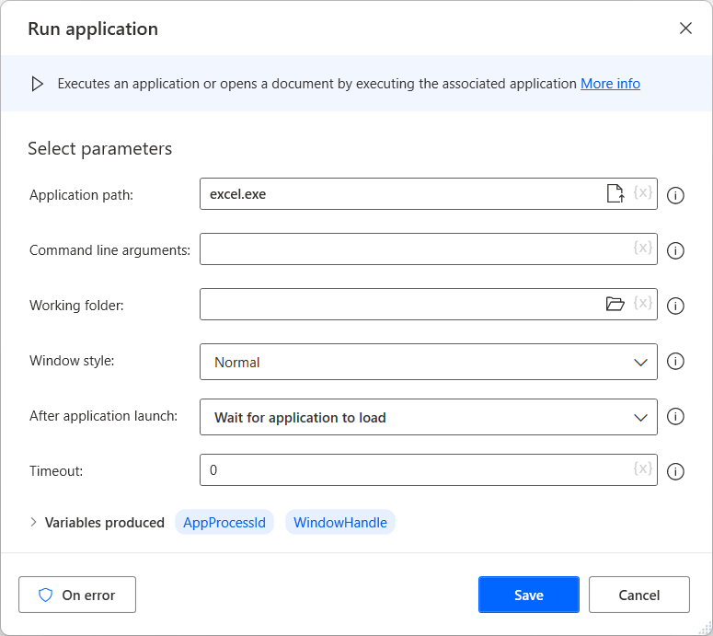

1. Launch Excel, either manually or by running the flow.
2. Select the **Recorder** button in the flow designer to launch the recorder.

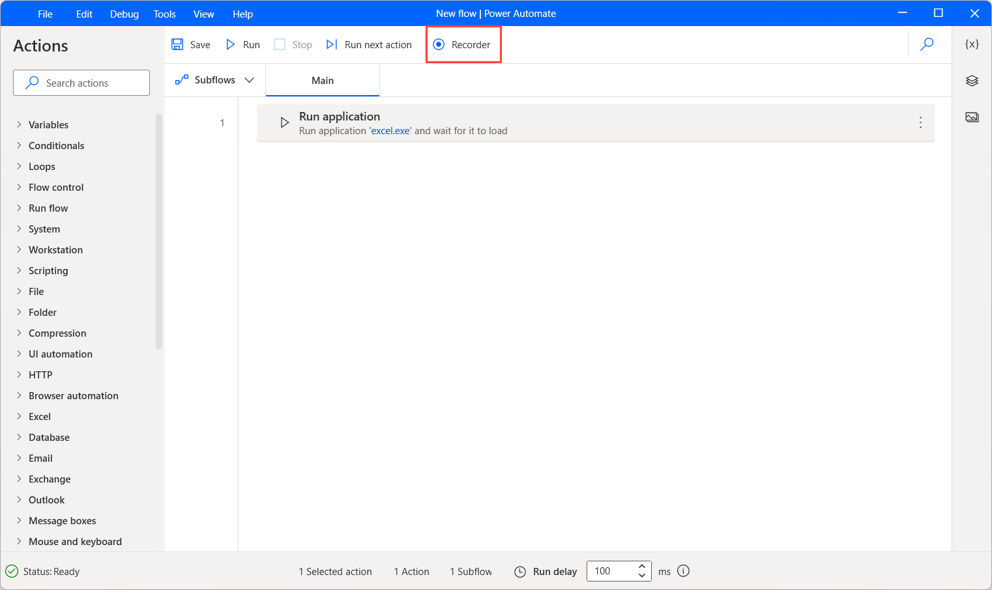

1. Select **Blank workbook** in the open Excel window to create a new empty workbook.
2. Select the entire first row, and then assign it a background color.
3. In this step, the recorder window should look like the following example. Optionally, you can add comments to describe the purpose of each step.

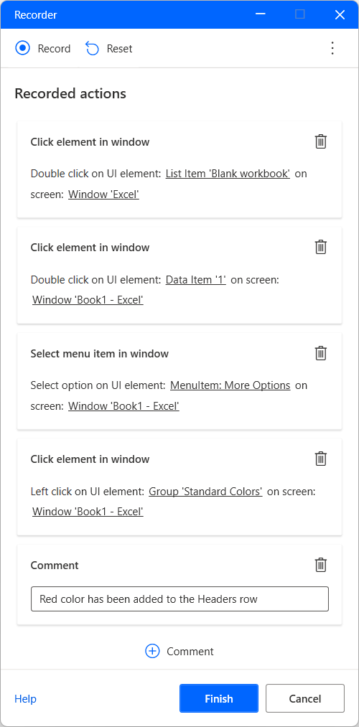

1. Lastly, press **Finish** to generate the corresponding actions in the flow designer.

